Muhammad Shoaib/Saad Salim/Mubeen Ahmed

Abstract

To Create a Database Program using Oracle and C#.Net

Proposal

Library Management System

Idea: The basic idea of this project is to create a Library Management System using Oracle Database and C#.Net Technologies.

Brief Description: **Library management** is a sub-discipline of [institutional management](http://en.wikipedia.org/wiki/Management) that focuses on specific issues faced by libraries and library management professionals. Library management encompasses normal management tasks as well as [intellectual freedom](http://en.wikipedia.org/wiki/Intellectual_freedom), [anti-censorship](http://en.wikipedia.org/wiki/Censorship), and [fundraising](http://en.wikipedia.org/wiki/Fundraising) tasks. Issues faced in library management frequently overlap those faced in management of [non-profit organizations](http://en.wikipedia.org/wiki/Non-profit_organization).[[1]](http://en.wikipedia.org/wiki/Library_management#cite_note-1)

Basic functions[[edit](http://en.wikipedia.org/w/index.php?title=Library_management&action=edit&section=1)]

Basic tasks in library management include:

* planning the [acquisition of materials](http://en.wikipedia.org/wiki/Library_acquisitions)
* negotiating borrowing materials from other libraries
* selection of library materials
* stacks maintenance
* fee collection in proper way
* membership management
* responding to [challenges](http://en.wikipedia.org/wiki/Challenge_(literature))
* approving and designing events
* fundraising

Application Process Flow:

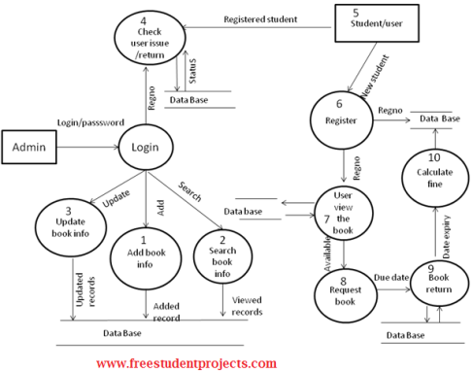

ER-Diagram:

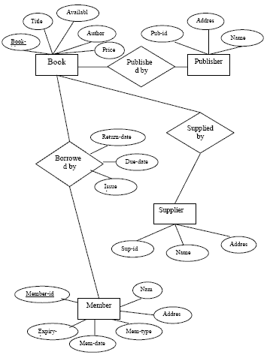

Conclusion:

This was an effort to develop a simple Library Management System which may be useful in a Library to insert, store, handle and retrieve information about books. I hope you will like it.